# **Practical – 1**

**AIM: Study of different software engineering models**

* **What is Software Model?**

A software model is an abstract representation of the software development process, outlining the stages, tasks, and deliverables involved. It helps in understanding and managing the complexities of software engineering by providing a structured approach to development.

**Characteristics of Software Models**

**Abstraction:** Software models simplify complex systems by focusing on essential features while omitting unnecessary details. This allows stakeholders to grasp the core functionalities

**Perspective:** Models can provide different views of the software, such as structural, behavioural, or informational perspectives. This multifaceted approach helps in addressing specific concerns and facilitates better communication among team members.

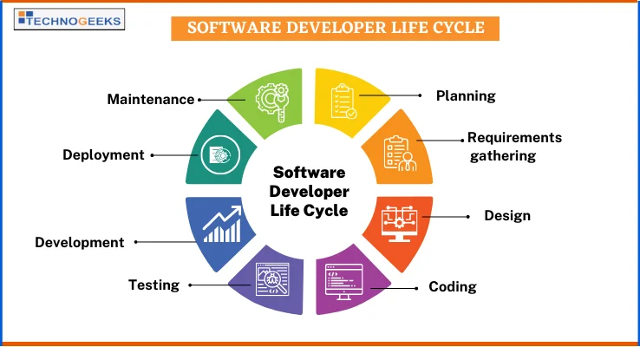**Communication:** They serve as a common language for developers, stakeholders, and clients, enabling effective discussions about the software's design, functionality, and requirements.

* **What is SDLC (Software Development Life Cycle)?**

The Software Development Life Cycle (SDLC) is a structured process used for developing software applications. It outlines the various stages involved in the development of software, from initial concept to deployment and maintenance. The SDLC provides a systematic approach to software development, ensuring that the final product meets the specified requirements and quality standards.

* **Types of SDLC**

1. **Waterfall Model**

* **Description**: The Waterfall model is a linear and sequential approach where each phase must be completed before the next one begins. It is straightforward and easy to understand.
* **Phases**: Requirements, Design, Implementation, Testing, Deployment, Maintenance.
* **Advantages**: Simple to manage, clear milestones, and well-defined documentation.
* 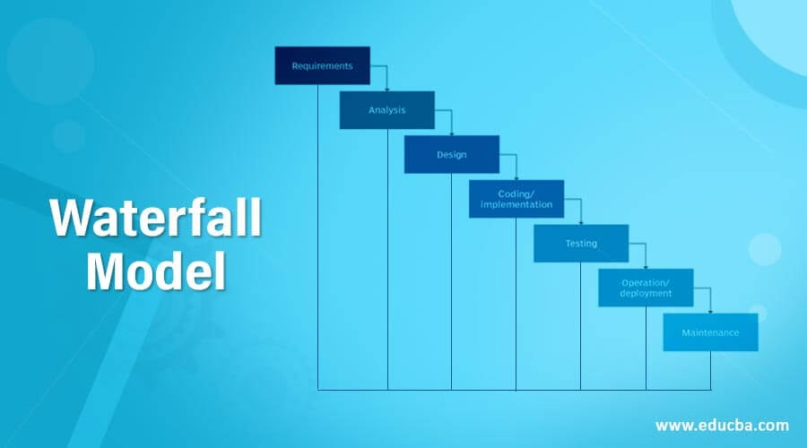**Disadvantages**: Inflexible to changes, late testing, and not suitable for complex or evolving projects.

1. **Spiral Model**

* **Description**: The Spiral model combines iterative development with the systematic aspects of the Waterfall model. It focuses on risk assessment and reduction through repeated cycles (spirals).
* **Phases**: Planning, Risk Analysis, Engineering, Evaluation, and Repeat.
* **Advantages**: Strong emphasis on risk management, flexibility, and allows for incremental releases.
* **Disadvantages**: Can be complex to manage, requires expertise in risk assessment, and may lead to high costs.

1. **Scrum Model**

* **Description:** Scrum is an Agile framework that emphasizes iterative development, collaboration, and frequent delivery of functional product increments. It relies on structured roles, events, and artifacts to ensure transparency, inspection, and adaptation throughout the development process.
* **Phases:** Sprint Planning, Sprint Execution, Daily Scrum, Sprint Review, Sprint Retrospective
* **Advantages**: Enables flexibility, faster delivery, stakeholder involvement, and continuous improvement.
* **Disadvantages**:  
  Requires disciplined teamwork, experienced Scrum Master, and can struggle with fixed requirements.

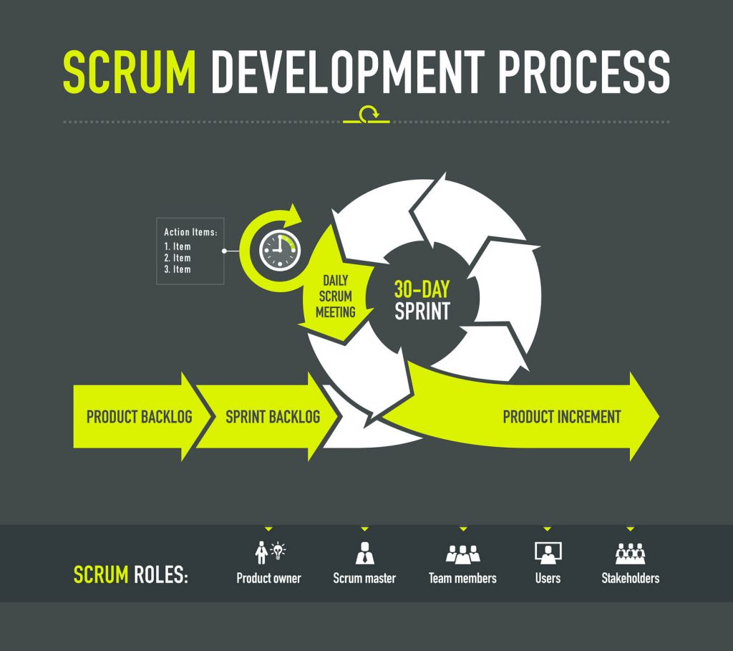

1. **V-Model (Verification and Validation Model)**

* **Description**: The V-Model is an extension of the Waterfall model that emphasizes verification and validation. Each development phase has a corresponding testing phase.
* **Phases**: Requirements, System Design, Architecture Design, Module Design, Implementation, followed by corresponding Testing phases.
* **Advantages**: Clear focus on testing, early detection of defects, and well-defined stages.
* 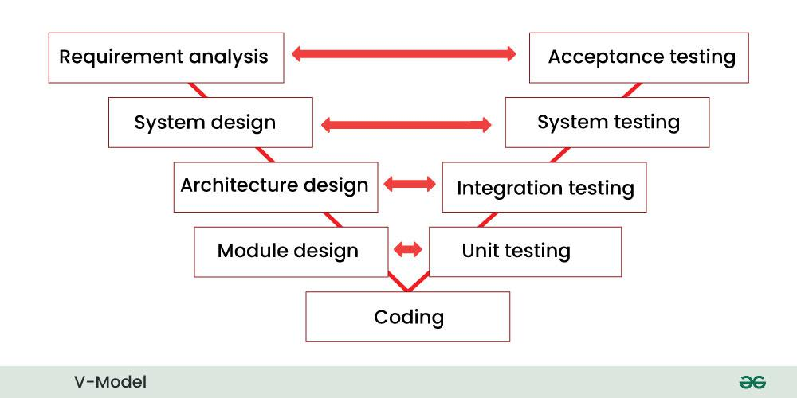**Disadvantages**: Inflexible to changes, similar limitations as the Waterfall model, and can be costly if changes are needed late in the process.

1. **Incremental Model**

* **Description**: The Incremental model divides the project into smaller, manageable parts (increments) that are developed and delivered in stages. Each increment adds functionality to the previous release.
* **Phases**: Planning, Design, Implementation, Testing, and Deployment for each increment.
* **Advantages**: Allows for partial implementation, easier to manage, and provides early delivery of functional software.
* 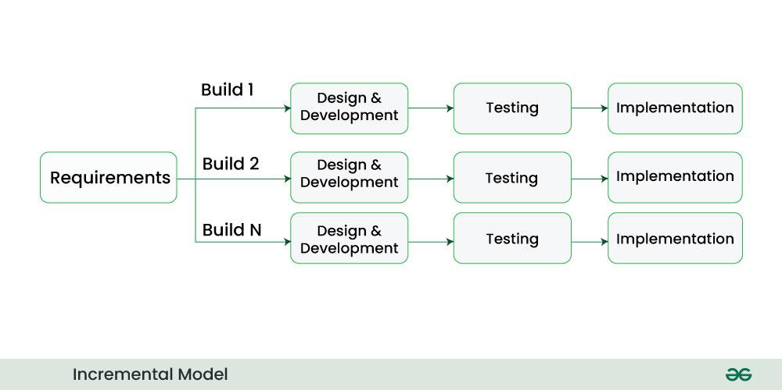**Disadvantages**: Requires good planning and design, and integration can be challenging.

1. **RAD (Rapid Application Development) Model**

* **Description**: The RAD model focuses on rapid prototyping and quick feedback from users. It emphasizes the use of software tools to speed up development.
* **Phases**: Requirements Planning, User Design, Construction, and Cutover.
* **Advantages**: Faster development, user involvement, and flexibility to changes.
* 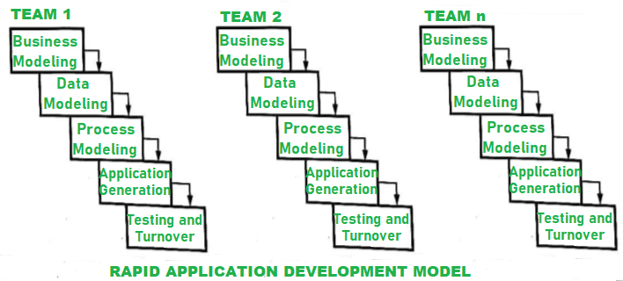**Disadvantages**: May lead to less control over the project, requires strong user involvement, and can be challenging for large projects.

1. **Agile Model**

* **Description**: The Agile model emphasizes iterative development, where requirements and solutions evolve through collaboration between self-organizing cross-functional teams. It promotes flexibility and customer feedback.
* **Phases**: Iterative cycles (sprints) of Planning, Design, Development, Testing, and Review.
* **Advantages**: High adaptability to changes, continuous feedback, and faster delivery of functional software.
* 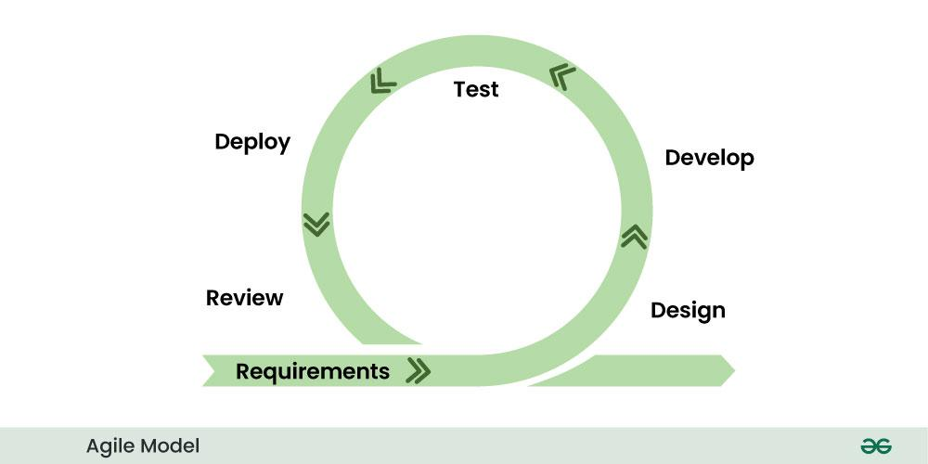**Disadvantages**: Requires active customer involvement, can lead to scope creep, and may lack comprehensive documentation.

**Why Agile is Suitable for the "RecordBook" Project**

The Agile methodology is the most appropriate approach for the "RecordBook" project due to its ability to adapt to evolving requirements, deliver functional increments rapidly, and prioritize user satisfaction. Below are detailed reasons supporting this choice:

1. **Dynamic Requirements:**

* Nature of the Project: The "RecordBook" website is user-centric, focusing on simplifying complex tasks like inventory management and financial tracking. Dynamic feedback from users will play a crucial role in refining the product.
* Iterative Refinement: Agile’s iterative approach ensures that enhancements based on feedback—such as improved navigation or feature tweaks—can be incorporated without disrupting the development process.
* Adaptability: Changes in market demands, stakeholder priorities, or technological trends can be addressed seamlessly, ensuring the project remains relevant.

1. **Incremental Delivery:**
   * With Agile, the project can be divided into small, manageable increments. For instance:
     + Phase 1: User login and navigation modules.
     + Phase 2: Inventory management module.
     + Phase 3: Financial transaction tracking.
     + Phase 4: Testing and optimization for responsiveness and reliability.
   * This approach ensures timely delivery of functional parts of the project.
2. **Collaboration and Feedback:**
   * Agile encourages continuous collaboration among developers, designers, and stakeholders. Regular feedback loops ensure the final product meets user expectations.
3. **Quality Assurance:**
   * Agile emphasizes testing at every iteration. This ensures that bugs are identified early, resulting in a reliable and high-performing application.
4. **Flexibility in Development:**

* **Non-Functional Requirements**: Agile supports iterative optimization for performance metrics like:
  + **Responsiveness**: Ensuring the website performs well on various devices (desktops, tablets, smartphones).
  + **Reliability**: Minimizing downtime, handling concurrent users, and ensuring consistent performance under heavy load.
* **Change Management**: Agile embraces evolving business goals or market demands, allowing modifications to requirements without disrupting progress.